L09-DBS301-Create alter and more

You will **create tables** first, then **add / modify /remove some columns** and finally **add / modify / remove some constraints** in this lab.

1. Create table SALESREP and load it with data from table EMPLOYEES table. Use only the equivalent columns from EMPLOYEE as shown below. (Do NOT create this table from scratch), AND only for people in department 80.

*SALESREP*

Column Type

RepId NUMBER (6)

FName VARCHAR2(20)

LName VARCHAR2(25)

Phone# VARCHAR2(20) ALL these columns’ data types match ones

Salary NUMBER(8,2) in table EMPLOYEES

Commission NUMBER(2,2)

**You will have exactly 3 rows here**.

Ans -1 )

Statement:

create table salesrep as

(select employee_id "RepId", first_name "FName", last_name "LName", phone_number "Phone#", Salary, commission_pct "Commission"

from employees

where department_id = 80);

Output:

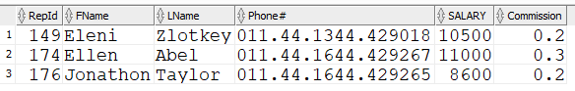

2a. Create CUST table.

CREATE TABLE CUST

(CUST# NUMBER(6),

CUSTNAME VARCHAR2(30),

CITY VARCHAR2(20),

RATING CHAR(1),

COMMENTS VARCHAR2(200),

SALESREP# NUMBER(7)

)

The constraints were left off in the above. The constraints shown below are what would normally be applied as shown. These were applied at the table level

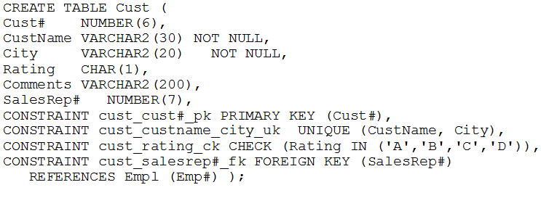

Load the table with these values in the chart. Some of the inserts have been done for you.

See below the chart

|  |  |  |  |  |
| --- | --- | --- | --- | --- |
| **CUST#** | **CUSTNAME** | **CITY** | **RAT** | **SALESREP#** |
| 501 | **ABC LTD.** | Montreal | C | 201 |
| 502 | **Black Giant** | Ottawa | B | 202 |
| 503 | **Mother Goose** | London | B | 202 |
| 701 | **BLUE SKY LTD** | Vancouver | B | 102 |
| 702 | **MIKE and SAM Inc.** | Kingston | A | 107 |
| 703 | **RED PLANET** | Mississauga | C | 107 |
| 717 | **BLUE SKY LTD** | Regina | D | 102 |

7 rows selected.

NOTE: Caution that copying from WORD will create errors if WORD is using quotes that look like ‘this’

SQL needs straight quotes like 'this'

These have been corrected for you

INSERT INTO CUST VALUES (501, 'ABC LTD', 'Montreal', 'C', NULL, 201)

Insert the rest of the rows. Here is a few but not all of them done for you

**INSERT INTO CUST values (701, 'MIKE and SAM inc.', 'Kingston', 'A', NULL, 102);**

INSERT INTO CUST values (703, 'RED PLANET', 'Mississauga', 'C', NULL, 107);

INSERT INTO CUST values (717, 'blue sky ltd', 'Regina', 'D', NULL, 102);

Statements:

insert into cust values (502,'Black Giant','Ottawa', 'B',NULL,202);

insert into cust values (503,'Mother Goose','London', 'B',NULL,202);

**insert into cust values (701,'BLUE SKY LTD','Vancouver', 'B',NULL,102);**

Output:

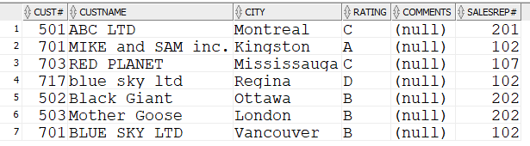

2b. Create table GOODCUST **from table CUST** by using following columns (do NOT create this table from scratch), but only if their rating is A or B.

*GOODCUST*

Column Type

CustId NUMBER (6)

Name VARCHAR2(30)

Location VARCHAR2(20) 🡪 ALL these columns’ data types match ones

RepId NUMBER(7) in table CUST

**🡪 You will have exactly 4 rows here.**

|  |  |  |  |
| --- | --- | --- | --- |
| **CUSTID** | **NAME** | **LOCATION** | **REPID** |
| 502 | Black Giant | Ottawa | 202 |
| 503 | Mother Goose | London | 202 |
| 504 | BLUE SKY LTD | Vancouver | 202 |
| 701 | MIKE and SAM inc. | Kingston | 10 |

Statement:

create table GOODCUST as

( select cust# "CustId", custname "Name", city "Location", salesrep# "RepId"

from cust

where rating IN ('B','A')

);

Output:

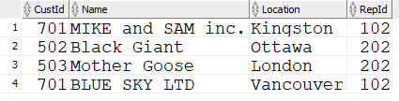

3. Now add new column to table SALESREP called JobCode that will be of variable character type with maximum length of 12. Do a DESC SALESREP to ensure it executed

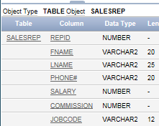

Statement:

alter table salesrep

add "JobCode" varchar2(12);

Output:

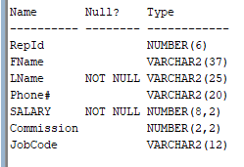

//Picture taken after Q5

4. Declare column Salary in table SALESREP as mandatory one and

Column Location in table GOODCUST as optional one. You can see location is already optional.

GODCUST before looks like the following

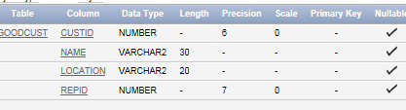

AFTER the change it would look as follows:

|  |  |  |  |  |  |  |  |  |  |
| --- | --- | --- | --- | --- | --- | --- | --- | --- | --- |
| **Table** | **Column** | **Data Type** | **Length** | **Precision** | **Scale** | **Primary Key** | **Nullable** | **Default** | **Comment** |
| [SALESREP](javascript:ret_Column('RON.SALESREP');) | [REPID](javascript:ret_Column('REPID');) | NUMBER | - | 6 | 0 | 1 | - | - | - |
|  | [FNAME](javascript:ret_Column('FNAME');) | VARCHAR2 | 37 | - | - | - | nullable | - | - |
|  | [LNAME](javascript:ret_Column('LNAME');) | VARCHAR2 | 25 | - | - | - | - | - | - |
|  | [PHONE#](javascript:ret_Column('PHONE#');) | VARCHAR2 | 20 | - | - | - | nullable | - | - |
|  | [SALARY](javascript:ret_Column('SALARY');) | NUMBER | - | 8 | 2 | - | - | - | - |
|  | [COMMISSION](javascript:ret_Column('COMMISSION');) | NUMBER | - | 2 | 2 | - | nullable | - | - |
|  | [JOBCODE](javascript:ret_Column('JOBCODE');) | VARCHAR2 | 12 | - | - | - | nullable |  |  |
|  |  |  |  |  |  |  |  |  |  |

Statement:

alter table salesrep

modify salary not null;

Output:



5. Lengthen FNAME in SALESREP to 37. The result of a DESCIBE should show it happening

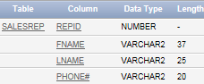

Statement:

alter table salesrep

modify "FName" varchar2(37);

Output:



You can only decrease the size or length of NAME in GOODCUST to the maximum length of data already stored. Do it by using SQL and not by looking at each entry and counting the characters. May take two SQL statements

6. Now get rid of the column JobCode in table SALESREP in a way that will not affect daily performance.

Statement:

alter table salesrep

drop column "JobCode";

Output:

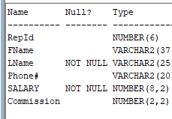

7. Declare PK constraints in both new tables 🡪 RepId and CustId

Statement:

alter table goodcust

add constraint CUSTID_PK

PRIMARY KEY("CustId");

alter table salesrep

add constraint REPID_PK

PRIMARY KEY("RepId");

Output:





8. Declare UK constraints in both new tables 🡪 Phone# and Name

Statement:

alter table goodcust

add constraint NAME_UK

Unique ("Name");

ALTER TABLE SALESREP

add constraint phone_uk

unique ("Phone#");

Output:

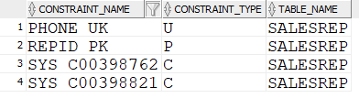

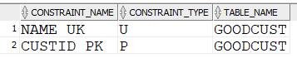

9. Restrict amount of Salary column to be in the range [6000, 12000] and Commission to be not more than 50%.

Statement:

alter table salesrep

add constraint salary_ck

check (SALARY BETWEEN 6000 AND 12000);

ALTER TABLE SALESREP

ADD CONSTRAINT COMMISSION_CK

CHECK ("Commission" <= 0.5);

Output:

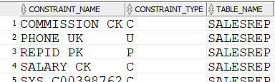

10. Ensure that only valid RepId numbers from table SALESREP may be entered in the table GOODCUST. Why this statement has failed?

RESULT:

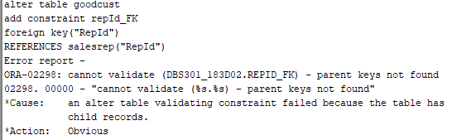

Obviously the table has child records so you cannot add a foreign key.

11. Firstly write down the values for RepId column in table GOODCUST and then make all these values blank. Now redo the question 10. Was it successful?

Previous values for goodcust:

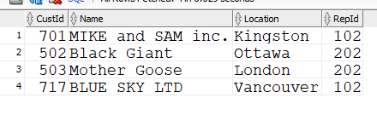

12. Disable this FK constraint now and enter old values for RepId in table GOODCUST and save them. Then try to enable your FK constraint. What happened?

Table was altered. Constraint FK made.

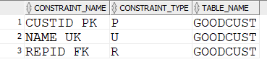

13. Get rid of this FK constraint. Then modify your CK constraint from question 9 to allow Salary amounts from 5000 to 15000.

alter table goodcust

drop constraint repId_FK;

alter table salesrep

drop constraint salary_ck;

alter table salesrep

add constraint salary_ck

check (SALARY BETWEEN 5000 and 15000);

14. Describe both new tables SALESREP and GOODCUST and then show all constraints

for these two tables by running the following query:

SELECT constraint_name, constraint_type, search_condition, table_name

FROM user_constraints

WHERE table_name IN ('SALESREP','GOODCUST')

ORDER BY 4 , 2

